Things you can find on the internet (don’t worry if you can’t find the answers, this is just for fun, and you should be able to find most of these answers after taking the class):

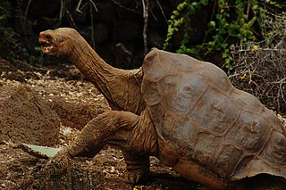
What is this a picture of? Who took this picture?

What is CLX46V? What does it have to do with Lansing, Michigan?

What is N975HP? Where is it now? Where has it been?

What is the maximum pH of a pickle sold in the United States? Where is this rule written?

Extra Challenge: What is this a picture of? Why does this thing have to be treated differently than usual?


